**Practical Number 4:** **Webpage Demonstrating Connection-Oriented Architecture (ASP.NET Web Forms with SQL Server Database)**

A **connection-oriented architecture** involves establishing a persistent connection between the client and server. This is typically demonstrated using **ADO.NET with SQL Server**, where a connection is opened, data is fetched, and then the connection is closed.

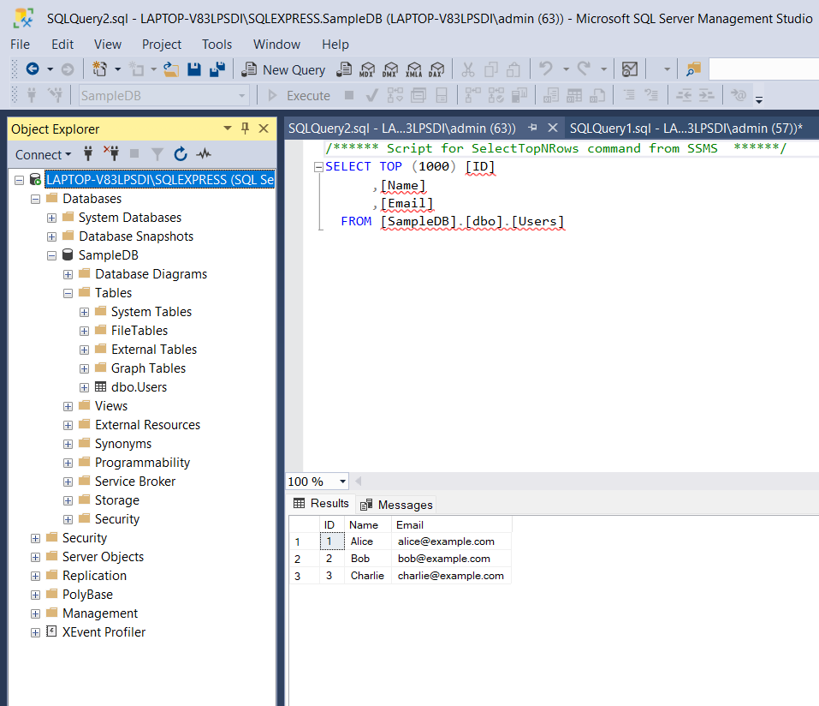

**📌 Step 1: Create SQL Server Table**

Run the following SQL script in **SQL Server Management Studio (SSMS)**:

CREATE DATABASE SampleDB;

USE SampleDB;

CREATE TABLE Users (

ID INT IDENTITY(1,1) PRIMARY KEY,

Name NVARCHAR(50),

Email NVARCHAR(100)

);

INSERT INTO Users (Name, Email) VALUES

('Alice', 'alice@example.com'),

('Bob', 'bob@example.com'),

('Charlie', 'charlie@example.com');

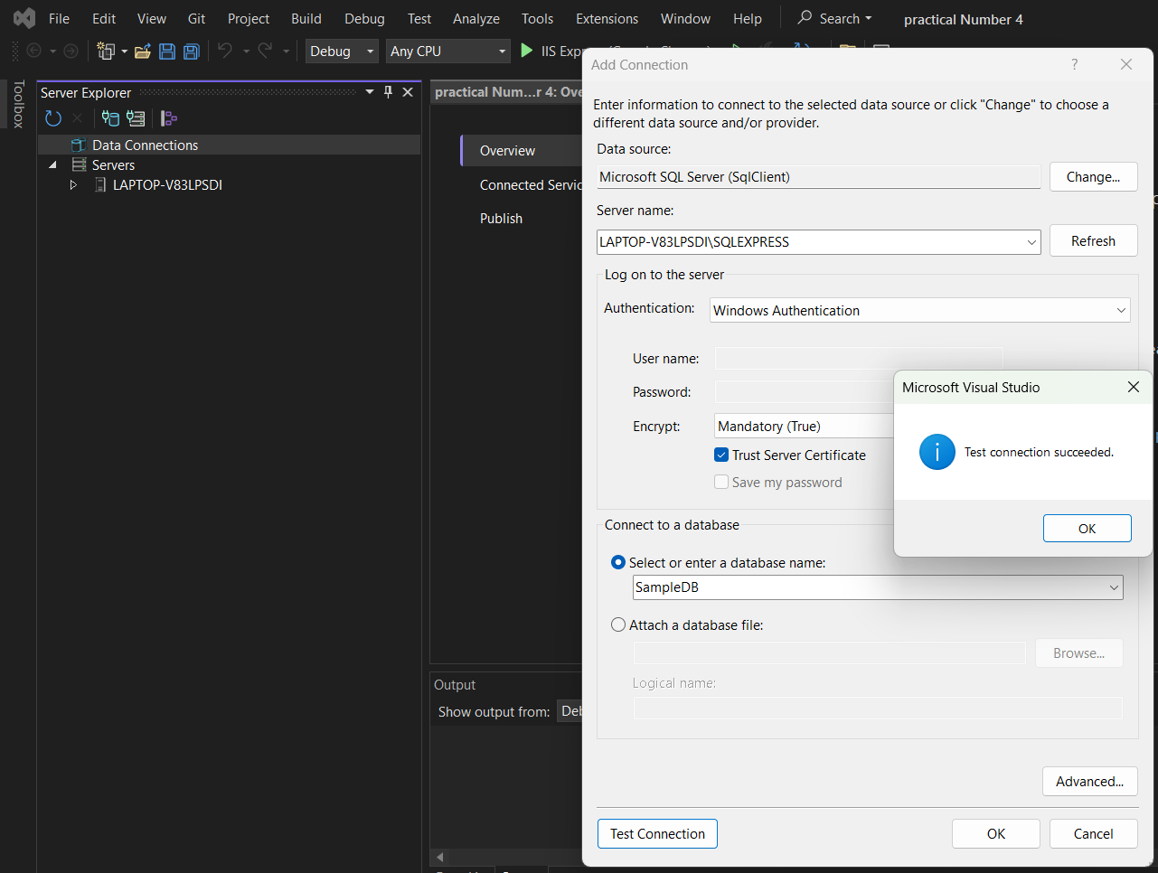=

**📌 Step 2: Design web form (Frontend UI)**

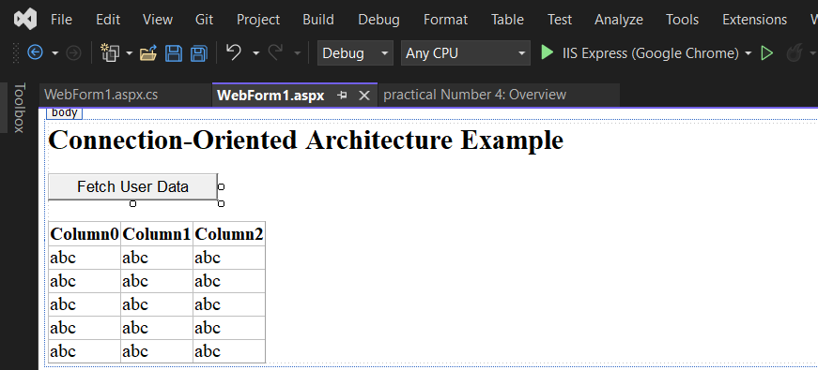

<%@ Page Language="C#" AutoEventWireup="true" CodeBehind="WebForm1.aspx.cs" Inherits="practical_Number_4.WebForm1" %>

<!DOCTYPE html>

<html>

<head runat="server">

<title>Connection-Oriented Architecture</title>

</head>

<body>

<form id="form1" runat="server">

<h2>Connection-Oriented Architecture Example</h2>

<asp:Button ID="FetchDataButton" runat="server" Text="Fetch User Data" OnClick="FetchDataButton_Click" />

<br /><br />

<asp:GridView ID="UsersGridView" runat="server" AutoGenerateColumns="true" BorderWidth="1" />

</form>

</body>

</html>

**📌 Step 3: Code-Behind**

using System;

using System.Collections.Generic;

using System.Data.SqlClient;

using System.Data;

using System.Linq;

using System.Web;

using System.Web.UI;

using System.Web.UI.WebControls;

namespace practical_Number_4

{

public partial class WebForm1 : System.Web.UI.Page

{

protected void Page_Load(object sender, EventArgs e)

{

}

protected void FetchDataButton_Click(object sender, EventArgs e)

{

// Define the connection string (Update with your server details)

string connectionString = "Data Source=LAPTOP-V83LPSDI\\SQLEXPRESS;Initial Catalog=SampleDB;Integrated Security=True";

// Create a connection object

using (SqlConnection conn = new SqlConnection(connectionString))

{

try

{

conn.Open(); // Open the connection

// SQL query to fetch data

string query = "SELECT * FROM Users";

SqlDataAdapter da = new SqlDataAdapter(query, conn);

DataTable dt = new DataTable();

da.Fill(dt);

// Bind data to GridView

UsersGridView.DataSource = dt;

UsersGridView.DataBind();

}

catch (Exception ex)

{

Response.Write("<script>alert('Error: " + ex.Message + "');</script>");

}

} // Connection closes au

}

}

}

